**DAILY ONLINE ACTIVITIES SUMMARY**

|  |  |  |  |  |  |  |  |  |
| --- | --- | --- | --- | --- | --- | --- | --- | --- |
| **Date:** | **29-6-2020** | | | | | **Name:** | **Prajna** | |
| **Sem & Sec** | **8th sem ‘B’** | | | | | **USN:** | **4AL16CS067** | |
| **Online Test Summary** | | | | | | | | |
| **Subject** | | **-** | | | | | | |
| **Max. Marks** | | **-** | | **Score** | | | **-** | |
| **Certification Course Summary** | | | | | | | | |
| **Course** | **Introduction to CSS** | | | | | | | |
| **Certificate Provider** | | | **Great learning** | | **Duration** | | | **5hrs** |
| **Coding Challenges** | | | | | | | | |
| **Problem Statement:**1**.** Write a c program print given number is happy number or not. | | | | | | | | |
| **Status: Completed** | | | | | | | | |
| **Uploaded the report in GitHub**  **GitHub link:** | | | | | **Yes**  **https://github.com/alvas-education-foundation/prajna_k** | | | |
| **If yes Repository name** | | | | | **prajna_k** | | | |
| **Uploaded the report in slack** | | | | | **yes** | | | |

Online Test Details: (Attach the snapshot and briefly write the report for the same)

Certification Course Details: (Attach the snapshot and briefly write the report for the same)

Coding Challenges Details: (Attach the snapshot and briefly write the report for the same)

2) certification course

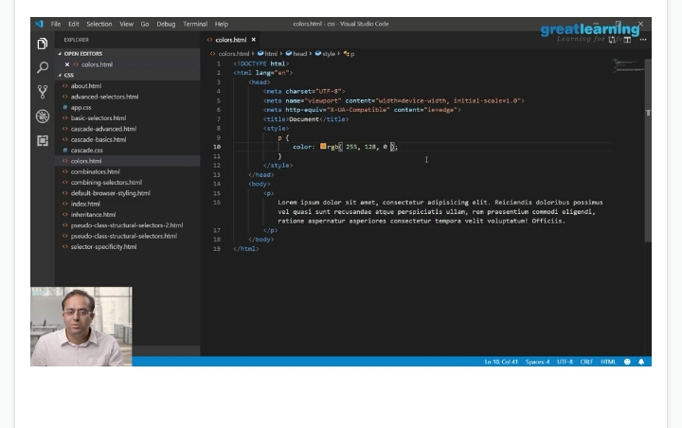

3) coding challenges

# include <stdio.h>

# include <math.h>

# include <stdlib.h>

int SumOfSquNum(int givno)

{

int SumOfSqr = 0;

while (givno)

{

SumOfSqr += (givno % 10) * (givno % 10);

givno /= 10;

}

return SumOfSqr;

}

bool checkHappy(int chkhn)

{

int slno, fstno;

slno = fstno = chkhn;

do

{

slno = SumOfSquNum(slno);

fstno = SumOfSquNum(SumOfSquNum(fstno));

}

while (slno != fstno);

return (slno == 1);

}

int main()

{

int hyno;

printf("\n\n Check whether a number is Happy number or not: \n");

printf(" ---------------------------------------------------\n");

printf(" Input a number: ");

scanf("%d",&hyno);

if (checkHappy(hyno))

printf("%d is a Happy number.\n",hyno);

else

printf("%d is not a Happy number.\n",hyno);

}

|  |
| --- |
|  |
|  |  |
|  |  |
|  |  |
|  |  |
|  |  |